**Project Design Phase-I**

**Solution Architecture**

|  |  |
| --- | --- |
| Date | 8 October 2022 |
| Team ID | PNT2022TMID24504 |
| Project Name | Project - News Tracker Application |
| Maximum Marks | 4 Marks |

**Solution Architecture Diagram:**

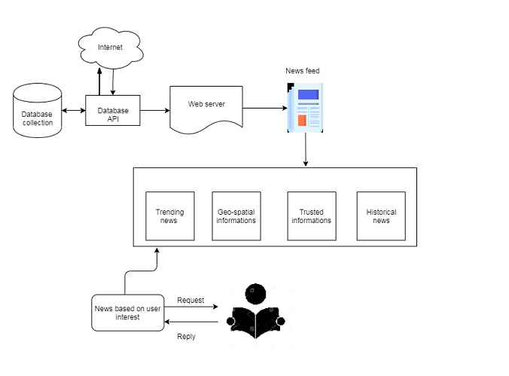

Architecture and data flow of the News Tracker Application